Top 5 UX Interview Design Question Themes

As with any job, UX interview questions tend to fall into a few categories:

* All About You
* All About Your Work
* All About Your Process
* What Makes You Tick?
* What Are Your Goals?

Let’s explore these topics further and review some of the most common UX interview questions that address these themes.

All About You

Interviewers like to begin with a series of questions that help them get to know you better: your personality, what motivates you, and how you operate. Typical questions that help them get to know you include:

1. Tell Me About Yourself

This is an alternative to “walk me through your resume.” The interviewer wants to know what your experience is and how it relates to the job you’re applying for. Don’t get too detailed (or too personal).

Walk them through your education, internships (if applicable), and previous jobs. Talk to them about why you’re leaving your existing job and what you’re looking for in your next position.

Overall, “tell me about yourself” is your opportunity to talk to the interviewer about why they should hire you. Next, they’ll want you to show them.

2. What Made You Go Into UX Design?

We assume you decided to pursue a career in UX design because it excites you and it’s something you’re passionate about, so this is your time to shine. Be honest (and enthusiastic) here. Don’t give answers along the lines of, “I heard you don’t need a college degree to be a UX designer,” or, “It pays well,” (both of which are true, but likely not what the interviewer wants to hear). Instead, consider focusing on the attributes that make you a good UX designer. Examples could include soft skills such as:

* Problem-solving: You’re a born problem solver and love finding new, creative ways to address challenges.
* Empathetic: You’re naturally empathetic and enjoy studying customer behavior and finding new ways to reach your target market.
* Curious: You love learning and enjoy staying up to date with new technological trends (be prepared to address some [2019 UX Design Trends](https://www.springboard.com/blog/ux-design-trends/) if asked).

You could also talk about your proficiency in time management, or switch over to a few of the hard skills required by UX designers. For instance, you could talk about:

* Visual elements: Have you always had a knack for visual design theory? Is it like fingernails across a chalkboard when you see improper use of layout, color, typography, icons, visual hierarchy, etc.?
* Storyboarding: Have you always been passionate about storyboarding and excited to learn you could make a career of it?
* Wireframing: Did you once take a class on wireframing and realize it was something that came naturally and that you’d love to do day in and day out?

Familiarize yourself with [what makes a good UX designer](https://www.springboard.com/blog/how-to-become-a-ux-designer/) and see how you can work a few of the attributes into your conversation.

3. Why Do You Want to Work Here?

This isn’t just a UX interview question; it’s a question asked in pretty much all interviews. This is where your prep work can help.

Is it a tech startup? Perhaps you’re interested in tech startups because you love the fast-paced, innovative culture that they possess. Is it a large corporation? Maybe you enjoy the stability proven companies offer and have heard great things about their principal UX designer and would love to learn from her.

Make sure you check out the company’s values in advance and align your answers with them. UX designer [Guy Ligertwood](https://medium.springboard.com/@ligertwoodguy) says he always tells interviewers that he’s “not fully sure if I want to work at the company, and that’s why I’m here: to find out more.”

That’s a bit of a power move, though.

4. On the Spectrum of UX Researcher to UX Designer to Visual Designer, Where Do You See Yourself and Why?

Ligertwood researched the UX design interview process when he was looking for a new UX role last year and found that this was one of the most popular UX design interview questions. His advice? It’s “best not to bullshit here.”

We agree. There are a lot of different UX roles. Make sure you know in advance which position best suits your skill set and desires. If you need a refresher, take a look at [What Does a UX Designer Do? Roles Explained](https://www.springboard.com/blog/what-does-a-ux-designer-do/), which helps break down everything from a UX researcher’s responsibilities to a visual designer’s.

***Related****:*[*UX Researcher vs. UX Designer*](https://www.springboard.com/blog/ux-researcher-vs-ux-designer/)

All About Your Work

When an interviewer asks you what you’ve done, this is your time to shine. Bring out your portfolio. Bust out the real-world examples and be prepared to talk about why you did what you did.

5. Show Me Your Portfolio

We guarantee this will be one of the UX design interview questions you face. When an interviewer asks to see your portfolio, he doesn’t just want you to hand it over. He wants you to walk him through it so he can see not only your creative output but your way of thinking as well. Tell your interviewer why you designed things the way you did. Tell him who the target market was, what problem you were looking to solve, and why you went about solving it the way you did.

6. Take Me Through a Couple of Your Favorite Pieces in Your Portfolio

Walking someone through your portfolio can be hard as it’s difficult to give background and context on a project. Make sure you practice in advance so you don’t become flustered. Not all interviewers are UX designers, so make sure to practice with someone who isn’t in the design field as well as someone who is.

Communication is an important skill for a UX designer to have, so use this opportunity to show off your talent.

7. What Was Your Design Process for These Pieces?

Hint: research, design, usability testing.

The interviewer wants to see your thought process. He wants to see how you approached the problem and why you approached it the way you did. Make sure to touch on research: did you conduct user interviews yourself or rely on a team of UX researchers? Talk about the design process: make sure you tell the interviewer why you designed things the way you did. And lastly, talk about the usability testing. How did you validate your design?

8. What’s Your Favorite Project You’ve Ever Worked on?

Hopefully, your favorite project will be in your portfolio, so when walking the interviewer through your past work examples, make sure to highlight your favorites and why you enjoyed them.

Make sure to highlight what made this project different from the others. Was it a passion project of yours, so it was more personal for you? Or was it particularly challenging, causing you to approach it in a new, innovative way?

There’s no wrong answer. The interviewer is using this question to get to know you better, see what excites you, and further understand your way of thinking.

9. Tell Me About a Time When a Project Didn’t Go Exactly as Planned. How Did You Fix It?

“Tell me about a time when…” is a favorite prompt among interviewers and you may be asked for several “times when.”

In this instance, the interviewer wants to understand your problem-solving skills. They’ll also want to make sure you can stay calm under pressure. Everyone has been faced with a challenging project at one time or the another, so use past examples.

Consider talking about a time when there was a kink in the process, budget cuts, or factors outside of your control. But be careful not to point fingers. And make sure you don’t use an example where the problem was negligence on your part.

Bonus points if you can mention a [lesson learned](https://www.springboard.com/resources/guides/ux-design-lessons/).

10. What Are Some Websites and Apps Whose Design You Love? Why?

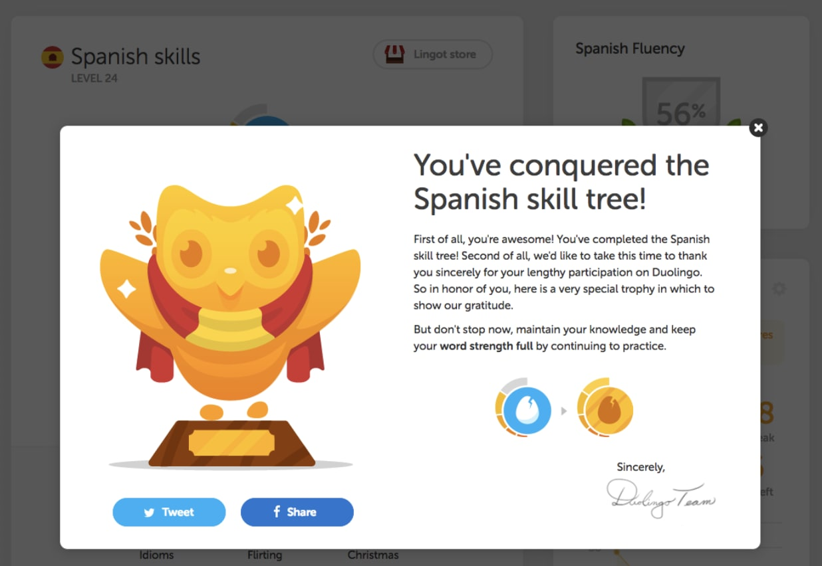

Take some time to think about your favorite websites and apps and why you like them. What makes them customer-friendly? Do they inspire you design-wise, and if so, how?

If you need a bit of inspiration, here are three of our favorites:

**Google:**Good UX design is about good function, not just aesthetics, and Google is the perfect example. You really can’t get more user-friendly than a page with one search area.

**Netflix:**Netflix is not only easy to operate but uses an algorithm that makes recommendations based off of your viewing history. It puts the customer’s desires at the forefront and delivers a personalized, easy-to-understand user interface.

**Duolingo:**If you’re a language nerd, chances are you’ve used Duolingo (or at least heard of it). The language-learning app is not only intuitive but fun. It’s built around gamification, so you feel more like you’re playing than learning.

[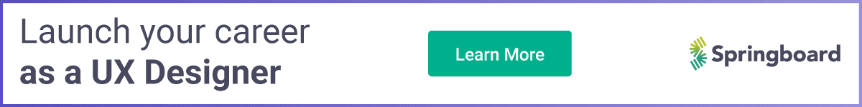](https://www.springboard.com/courses/ux-career-track/?source=blog&medium=middle_banner&campaign=ux_design_interview_questions)

All About Your Process

Design process questions are another favorite of UX design interviewers. They want to know your *entire*process, from initial concept to finished design. They’ll also want to know what you think UX is and what its goals are.

11. How Do You Define UX?

Please, please, please do not give a canned, textbook definition here. The interviewer already knows what UX is. He just wants to know how you’d describe it. If you’re unsure, do a bit of research.

***Related****:*[*What Is UX Design*](https://www.springboard.com/blog/what-is-ux-design-user-experience-experts-weigh-in/)*?*

One of our favorite ways to explain UX is through real-life examples. You could talk to them about Airbnb and how co-founder Joe Gebbia [credits a change in the user interface](http://firstround.com/review/How-design-thinking-transformed-Airbnb-from-failing-startup-to-billion-dollar-business/) with making it a $10 billion company. Or you could tell them why you agree with Jeff Bezos’ decision to allocate 100 times more budget for customer experience efforts than advertising in the early days of Amazon.

Just make sure to stress that UX design is what makes websites, apps, and other products as easy to use and customer-friendly as possible.

Next, you can tell them how *you* do it.

12. How Does UX Differ From Other Design Disciplines?

Sometimes this question is asked in silo and other times as a followup to “how do you define UX design.” The interviewer isn’t looking for you to define every design discipline. Rather, he wants to know how you think UX fits in.

Maybe he’ll ask you how UX design differs from graphic design, or maybe he’ll ask how it differs from UI. The trick to this answer is to convey that UX is about making things functional and UI (as well as other design disciplines) is about making things beautiful (think typography, colors, and specific layouts).

Sometimes companies combine UX and UI, and other times there are different teams for both. If you’re interviewing for a job that is solely dedicated to UX (and there’s a separate team for UI), it’s imperative that your prospective employer knows you can distinguish the two. If you’ve worked with a UI team before, consider giving an example of a project. Explain how *your* primary focus was usability and your teammates’ was aesthetics. If you have an example of this project in your portfolio, you can walk the interviewer through it.

***Related****:*[*UI vs. UX: A Culinary Comparison*](https://www.springboard.com/blog/ui-vs-ux-a-culinary-comparison/)

13. What’s Your Design Process?

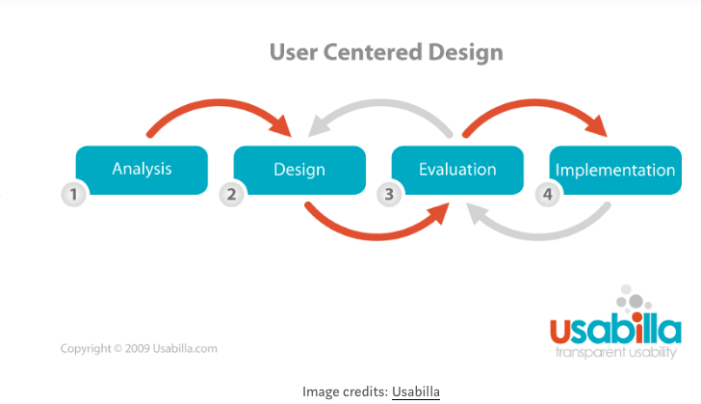

You should walk an interviewer through your process when you show him your portfolio, but often times he’ll flat out ask you what your design process is.

Rather than give a hypothetical process for a hypothetical project, walk the interviewer through another real-life example (you can bring out your portfolio again or you can just talk him through it).

If you don’t work on every step of the process, that’s OK, but make sure to touch on it so the interviewer knows your familiar with it. Nick Babich, editor-in-chief of UX Planet, suggests focusing on the [following areas](https://medium.springboard.com/the-7-questions-youll-be-asked-at-a-ux-design-interview-84f3214e0f29):

* [User Research](http://www.uxbooth.com/articles/complete-beginners-guide-to-design-research/)
* Usability
* Information Architecture
* User Interface Design
* [Interaction Design](http://www.uxbooth.com/articles/complete-beginners-guide-to-interaction-design/)
* [Experience Strategy](http://johnnyholland.org/2009/06/what-is-an-experience-strategy/)

We also recommend taking a user-centered approach, which shows your understanding of both the customer’s goals as well as the goals of the business. Keep in mind that different UX designers have different processes and that’s OK. Just make sure you can explain your rationale for why you approached the project the way you did.

14. What Inspires You?

When interviewers ask you where you find inspiration, or what blogs/magazines/etc. you read to stay up to date on current trends, they want to see what motivates you and they want to know that you’re eager to keep learning.

Talk about your [favorite design blogs](https://www.springboard.com/blog/best-blogs-on-ux-design/" \t "_blank) or [Twitter profiles](https://www.springboard.com/blog/ux-designers-to-follow/). Or talk about a few conferences you’ve attended, newsletters you subscribe to, or books you’ve read. If you’re not following any blogs right now, that needs to change. Here are a few of our favorites:

* [UX Booth:](http://www.uxbooth.com/) A thoughtful blog on UX design and strategy. UX Booth, which has been running since 2008, covers design philosophy, interaction design, analytics, and many more topics. The blog also pays attention to how the web is changing and what that means for user experience and interaction designers.
* [Boxes and Arrows](http://boxesandarrows.com/): Boxes and Arrows focuses on research methodology and design processes, serving as a handy guide to improving research methods, understanding audiences, and educating others on user experiences.
* [Smashing Magazine:](http://uxdesign.smashingmagazine.com/) A great resource on web design in general, Smashing Magazine has an extensive section on UX design. Find articles on everything from content strategy to coding to recovering from setbacks. Smashing Magazine also has a growing ebook library with additional resources.
* [52 Weeks of UX:](http://52weeksofux.com/) In 2010, HubSpot’s director of UX and Twitter’s principal designer set out to discover what exactly makes the user experience. This blog is the result. The duo published for a year, dissecting the problems encountered when designing for real people and posting some best practices.
* [Springboard](https://www.springboard.com/blog/): Obviously (although we may be a bit biased). Springboard’s blog covers key design principles, plus UX best practices and career advice.

15. How Do You Decide Which Features to Add to Your Product?

This is a tricky question because the answer depends on the context. We recommend using a real-life example that illustrates how you validated or rejected a hypothesis. Walk the interviewer through your process. Make sure to clearly address the business goals and user needs and walk the interviewer through the following:

* Who is the target market?
* What are the target market’s goals?
* What problems does this feature solve for the target market?

You can also talk about how you use user research to validate design decisions.

16. How Do You Put Yourself in the Mind of the Consumer?

As you know, UX design differs from other fields of design as it’s the most user-centric. You can tell the interviewer that you “always have your customer hat on,” but showing him *how*you do it is more impactful. Perhaps you do this by creating personas and learning the wants, needs, and even quirks of the personas. Or maybe you do this through research.

17. What Kind of Research Methods Do You Use When Starting a New Project?

There are a few ways to answer this question. The first is by being honest. Tell the interviewer what types of research you typically use. Do you rely solely on online surveys due to budget constraints but wish you could do more face-to-face interviews? Tell the interviewer that.

The important part here is to show your familiarity with the research process. Talk about what methods you use, what methods you *wish*you could use, and the pros and cons of both.

What Makes You Tick?

Most interviewers like to ask behavioral questions. These can be brutal, not because you don’t know *how* to answer them, but because you don’t know what the interviewer wants to hear. Let’s look at a few:

18. What Are Your Three Biggest Strengths?

This is the time to toot your own horn. Just make sure your strengths align with what the company is actually looking for!

We recommend preparing for this question in advance by revisiting the job description. For instance, consider this job description for [Nextdoor](https://www.glassdoor.com/job-listing/ux-designer-nextdoor-JV_IC1147401_KO0,11_KE12,20.htm?jl=3181744018&ctt=1557770636491" \t "_blank) in San Francisco:

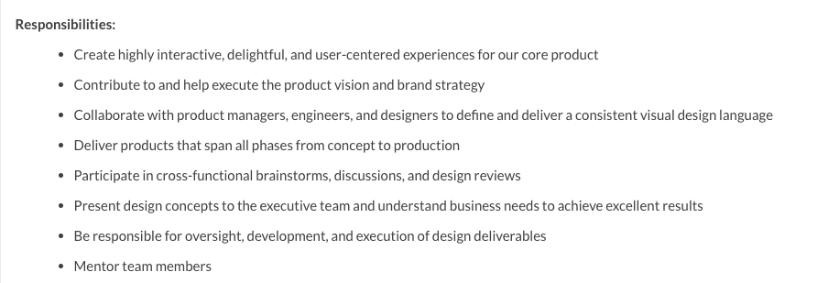

As you can see, Nextdoor wants someone who can create “highly interactive, delightful, and user-centered experiences.” They also want someone who can “mentor team members” and “participate in cross-functional brainstorms, discussion, and design reviews.” As such, you could say that your top three strengths are:

1. Empathy: You’re able to take a step back, put your biases aside, and put the customer and her needs first.
2. Leadership: You mentored several junior designers at your last job and loved watching them grow.
3. Collaboration: You love brainstorming with other teams, as each team has its own area of expertise and brings something new to the whiteboard.

If an interviewer asks you about your strengths, you can also assume they’ll ask you about your weaknesses.

19. What Is Your Biggest Weakness?

Telling a potential employer what you’re bad at seems counterintuitive. However, it’s a common question. If possible, try and frame your answers as positive weaknesses. Let’s take a look at the same job description for [NextDoor](https://www.glassdoor.com/job-listing/ux-designer-nextdoor-JV_IC1147401_KO0,11_KE12,20.htm?jl=3181744018&ctt=1557770636491" \t "_blank) in San Francisco to see what requirements they’re looking for:

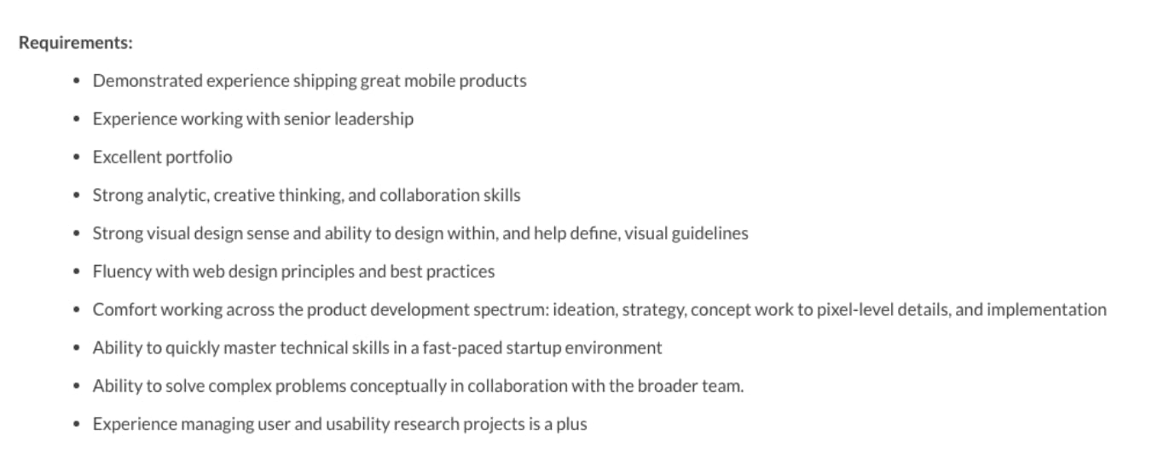

As you can see, they want someone who can handle a “fast-paced startup.” This is code for “there’s a lot going on and a lot of change,” so you could format one weakness as:

“I get bored if I’m not being challenged or staying busy.”

This shows the interviewer that you’ll thrive in a fast-paced, challenging environment. You could also say:

“I’ve been told I send too many emails after work hours.”

This shows that you’re a hard worker and always on, even once you’ve gone home. (But be sure that’s the job you want!)

20. How Do You Handle Negative Feedback?

Don’t just say “well.” Rather, say you’re open to all types of feedback as it helps you become a better UX designer. Perhaps give a few examples of feedback you received on a project and how you handled it.

You could talk about a former boss who was swift with negative feedback, but you liked to think of it as “constructive criticism.” Say you’d rather receive feedback from internal parties than real customers once a product has launched. You could tell the interviewer that you and your employers are all on the same team and if there’s something you could be doing better you’d want to discuss it.

21. What Type of Environment Do You Thrive in?

UX designers work with a variety of different teams within an organization, including engineers, product managers, fellow designers, marketing teams, and more. For some, this is a perk, for others, a challenge.

During an interview, a hiring manager will want to understand if you’re willing to collaborate with others and if you’re a team player.

22. How Do You Hand Over Your Designs to the Developers?

This is another question that will speak to your willingness to collaborate. Give a recent example of a project you worked on that can help illustrate your story.

The goal is to show that you’re OK signing off on a project and trusting that it’s safe in the developer’s hands.

23. Tell Me About a Time When You Disagreed With Your Team’s Recommendation. What Did You Do?

Data-driven answers are the best type of answers. Remember that. And when you can, talk about using data and proven results to make thoughtful recommendations and business decisions.

In this instance, you should talk about whether the recommendation was based on proven results or completely subjective. If you can, use an example where the recommendation was subjective (i.e., “the boss likes the color pink so we’re making the button pink”). As an example, you could say that you disagreed with the team’s recommendation because of your user research. Perhaps you had witnessed people interacting with prototypes and saw that they gravitated toward the color blue more often than the color pink. If possible, suggest conducting one more round of usability testing so you can A/B test a pink button against a blue button. Disagreements are better solved with objective data than subjective opinions.

***Related****:*[*Data-Driven Design: What It Is and Why It Matters*](https://www.springboard.com/blog/data-driven-design/)

**What Are Your Goals?**

Interviewers want to know if you plan on staying at their company long term and if you want to stay (and grow) in the position you’re applying for. As such, they’ll sometimes ask you where you see yourself in several years or what your career goals are.

24. Where Do You See Yourself in Five Years?

Long-term planning can be hard. It’s OK if you don’t know where you want to be in five years, but at least give the interviewer an idea.

If you’re interested in a job in UX design, we hope it’s a career you’d like to stay in. Talk about what that career path looks like for you. Do you want to become an expert in one particular field of UX? If so, talk about that, and how this position will help you get there. Is your ultimate goal to become a principal UX designer? That’s typically a 10-year goal, but talk about what you’ll do over the next five years to achieve that goal.

And it’s best to make clear that you see yourself remaining at that company.

25. What Excites You About This Position?

Employers want to know that you’re passionate about the position you’re applying for and not just in it for the money. Being excited about the company and the position are two very different things and—while this may be your dream company—if the position isn’t the right fit, then this probably isn’t the right job for you.

When answering, try to reference your career goals. How will this position help you hone an existing skill or teach you a new one? Also, what existing skills or experience do you have that make you an ideal candidate for this role?

Bonus Question: Do You Have Any Questions?

This is a standard interview closer, not just a UX design interview question. It shows that you paid attention during the interview and are actively engaged. Again, UX designers are supposed to be curious. If you walk out of the room without asking any questions, the interviewer will likely assume that you aren’t interested in the position.

We recommend that you ask each person you meet with (from the initial recruiter to the hiring manager) two or three good questions. Here are a few suggestions:

* Reference a topic discussed during the interview. Did they tell you about an upcoming project launch? You could ask what research techniques they used or how prototyping is going.
* Ask about the company culture. How do employees describe working there? What is the turnover rate?
* What makes a good UX designer? Feel free to throw some of their own questions back at them.

The questions can really be about anything. Just be engaged. Interviews are a two-way street, and you want to find out as much about the company as it does about you.

Final Thoughts

As we suggested at the beginning, there are no CliffsNotes on job interviews. There are, however, interview FAQs, and the above UX design interview questions represent some of the most popular ones that we’ve come across.

When it comes to interviewing, it’s impossible to overstate the importance of preparation. Make sure you research the company, its values, and its goals. Research the people you’ll be interviewing with. And most importantly, know the job description and its requirements inside and out so you can cater your answers toward them. (Move on to this post for a broader view on [how to get a UX job](https://www.springboard.com/blog/how-to-get-a-ux-job/).)

**Looking for a UX design course that includes one-on-one mentorship with an industry expert and support from a career coach? Check out our**[UX Career Track](https://www.springboard.com/workshops/ux-career-track?source=blog&medium=post&campaign=UXC&term=bottom&content=ux_interview)**now!**